****Three-Way Handshake****

**&  
Supercomputer**

**COMSATS University Islamabad**

Sahiwal Campus



***Usama Sarwar***

FA17-BS(CS)-090-B

***Usman Nasir***

Introduction to ICT

September 19, 2019

**Table of Contents**

Title Page No.

# THREE-WAY HANDSHAKE

## Abstract ………………………………………………………. 2

## Explanation ……………………………………………………... 3

## List of Figures

### Step 1: Sending SYN Segment

### Step 2: Reply with SYN-ACK

### Step 3: Client reply with ACK

## References ………………………………………………………. 5

# SUPERCOMPUTER

## Abstract …………………………………………………………. 6

## Explanation ……………………………………………………... 7

## Comparison of my machine with Supercomputer ……………… 10

## References ………………………………………………………. 11

**Abstract**

In broadcastings, a handshaking is an automatic method of concession between 2 human activity in between candidates through the conversation of data that establishes the protocols of a communication link at the beginning of the communication, before full communication begins. Signals are typically changed between 2 devices to determine a communication link. as an example, once a laptop communicates with another device like an electronic equipment, the 2 devices can signal one another that they're switched on and prepared to figure, yet on comply with that protocols are being employed.

**Explanation**

A three-way handshake is primarily accustomed produce a transmission control protocol socket association. It works when:

**Step 1**

A consumer node sends a SYN information packet over an IP network to a server on an equivalent or an external network. the target of this packet is to ask/infer if the server is open for brand spanking new connections.

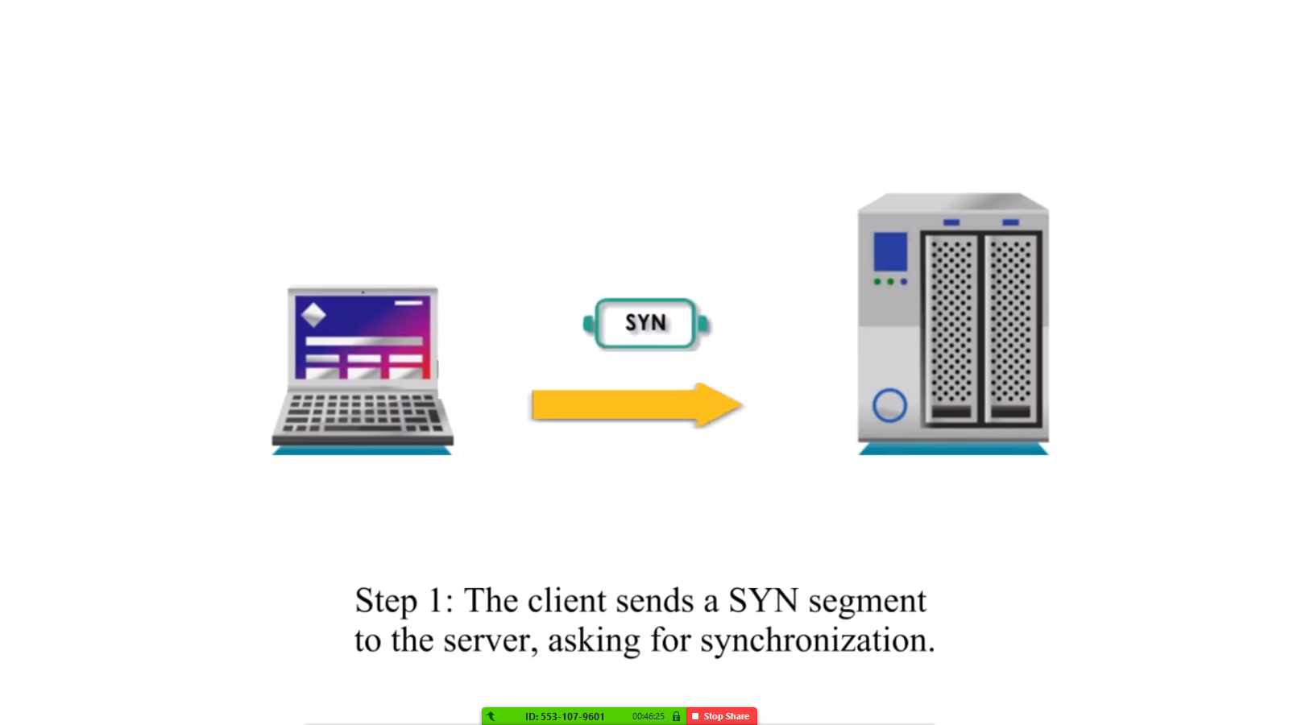

**Step 2**

The target server should have open ports that may settle for and initiate new connections. once the server receives the SYN packet from the consumer node, it responds and returns a confirmation receipt – the ACK packet or SYN/ACK packet.

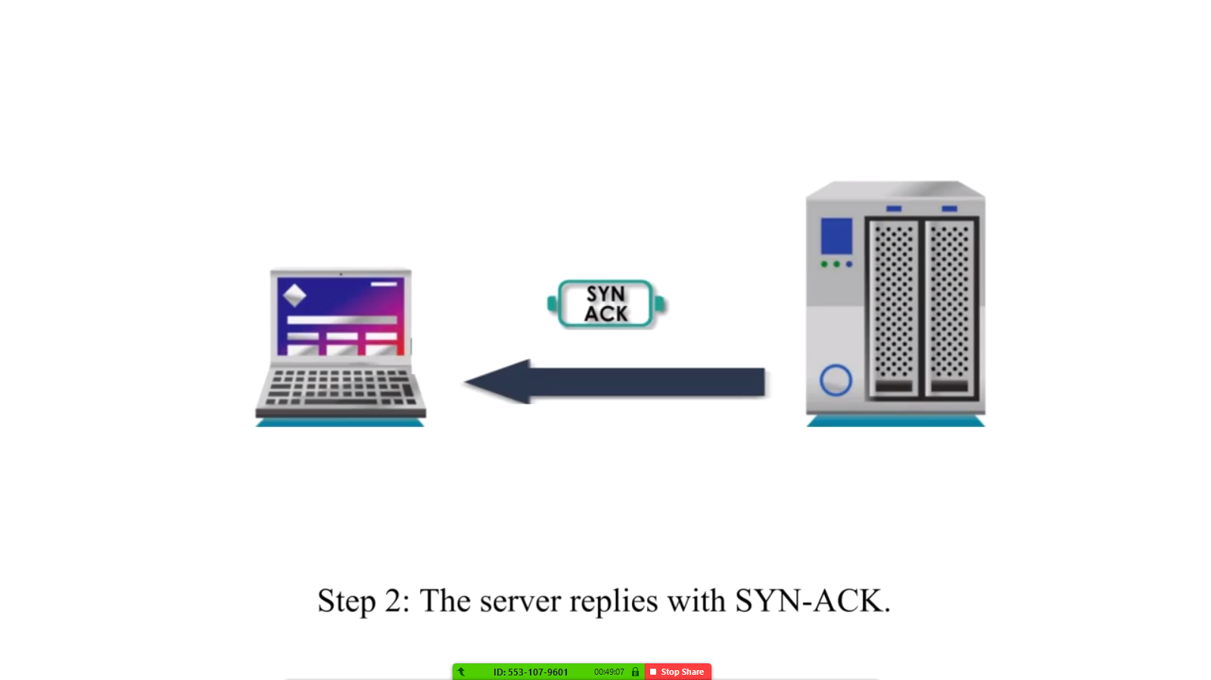

**Step 3**

The consumer node receives the SYN/ACK from the server and responds with an ACK packet.

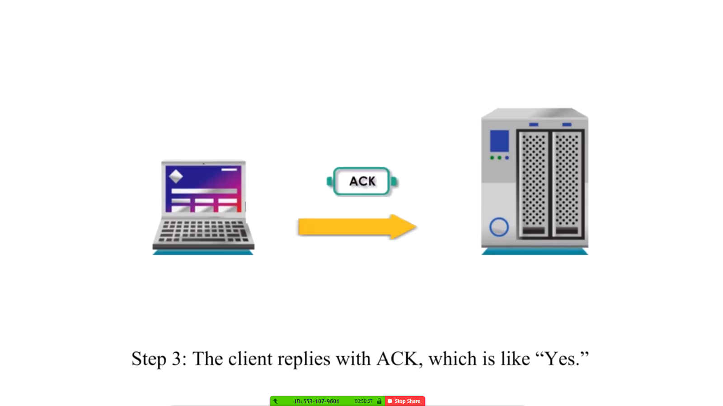

Upon completion of this method, the association is formed and also the host and server will communicate.

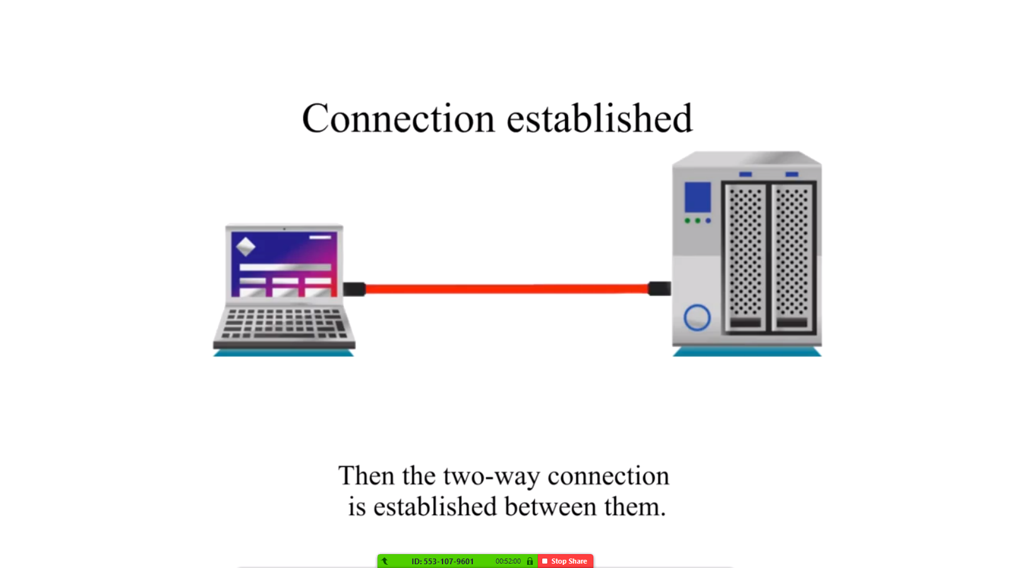

**References**

1. P. Amer, S. Iren, P. Conrad, "The Transport Layer: ", ACM Computing Surveys, vol. 31, no. 4, Dec. 1999.
2. J. Touch, "Dynamic Internet Overlay Deployment and Management Using the X-Bone", Computer Networks, pp. 117-135, July 2001.

**Abstract**

A supercomputer could be a pc with a high level of performance compared to an all-purpose computer. The performance of a mainframe computer is often measured in floating-point operations per second (FLOPS) rather than million instructions per second (MIPS). Since November 2017, all of the world's quickest five hundred supercomputers run Linux-based operating systems. further analysis is being conducted in China, the u. s., the EU Union, Taiwan and Japan to make even quicker, a lot of powerful and technologically superior exactable supercomputers.

**Explanation**

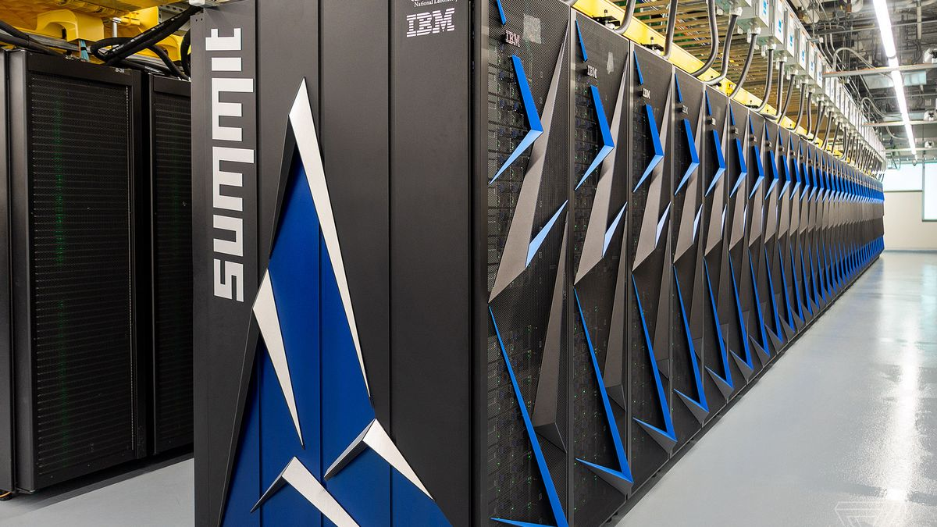

Source: [Summit IBM](https://www.google.com/url?sa=i&source=images&cd=&ved=2ahUKEwjXgZCDovbkAhVCOBoKHQL0AMoQjRx6BAgBEAQ&url=https%3A%2F%2Fwww.theverge.com%2Fcircuitbreaker%2F2018%2F6%2F12%2F17453918%2Fibm-summit-worlds-fastest-supercomputer-america-department-of-energy&psig=AOvVaw3rDVDjwFM9RosKk4KLeNkJ&ust=1569854523901169)

**IBM Supercomputer Summit**

**Sponsors** U.S. Department of Energy

**Operators** IBM

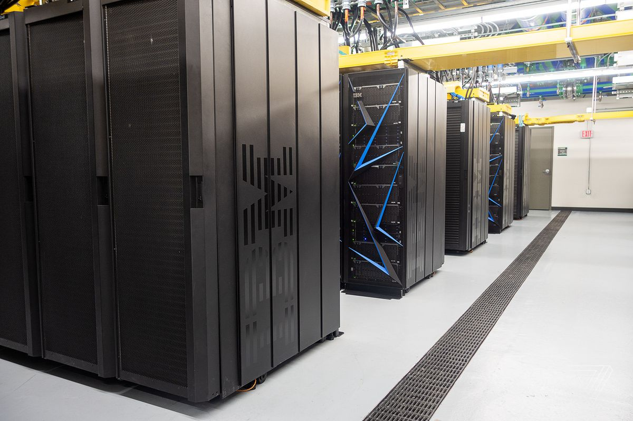

**Architecture** 9,216 POWER9 22-core CPUs

27,648 Nvidia Tesla V100 GPUs

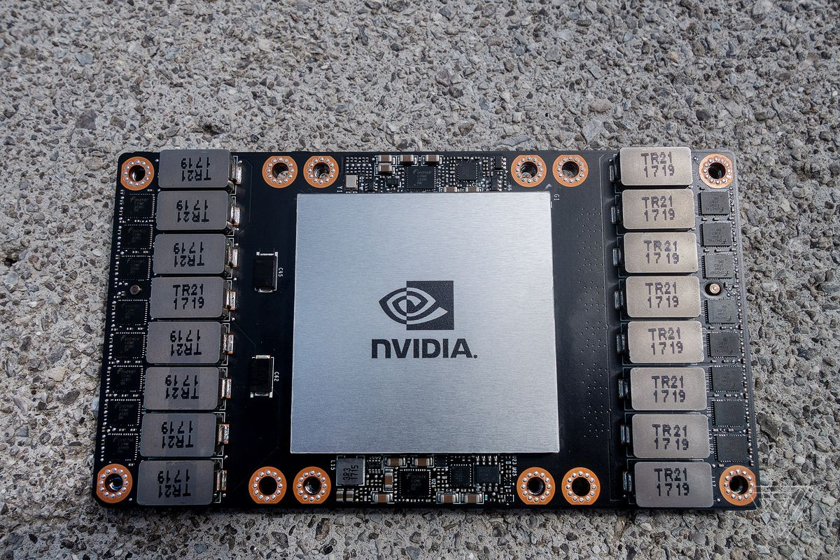

**Power** 13 MW

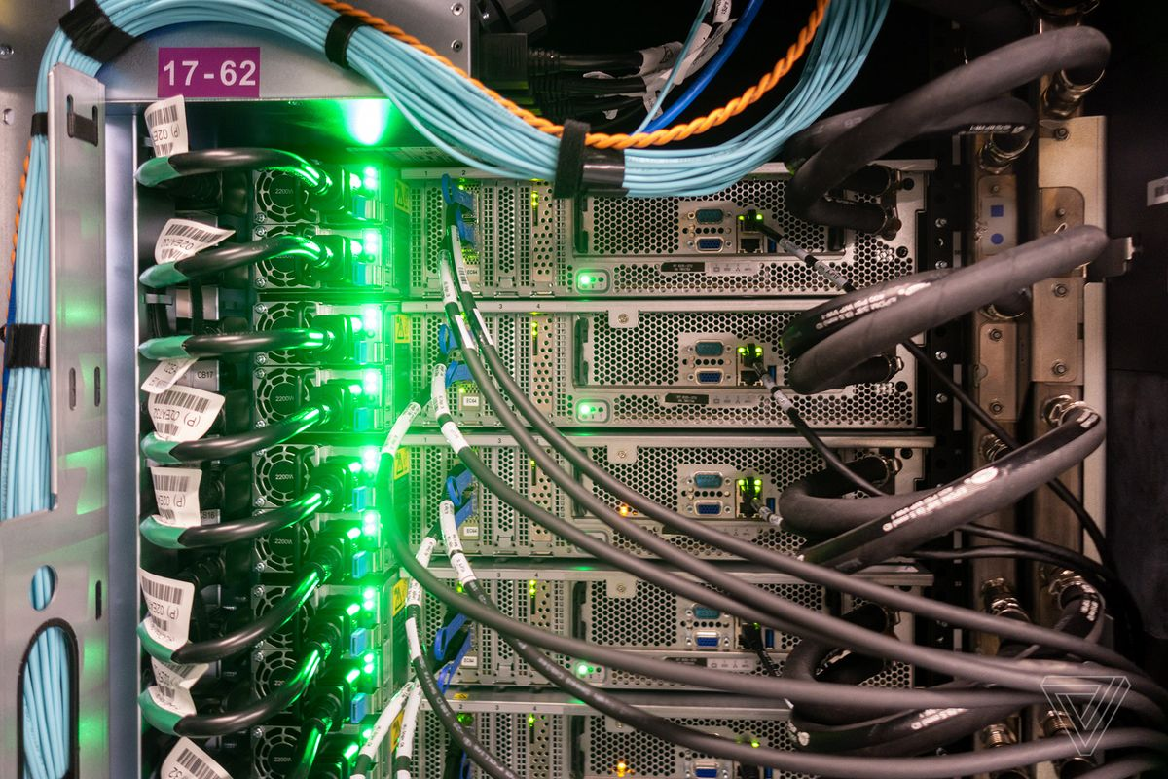

**Storage** 250 PB

**Speed**  200 petaflops (peak)

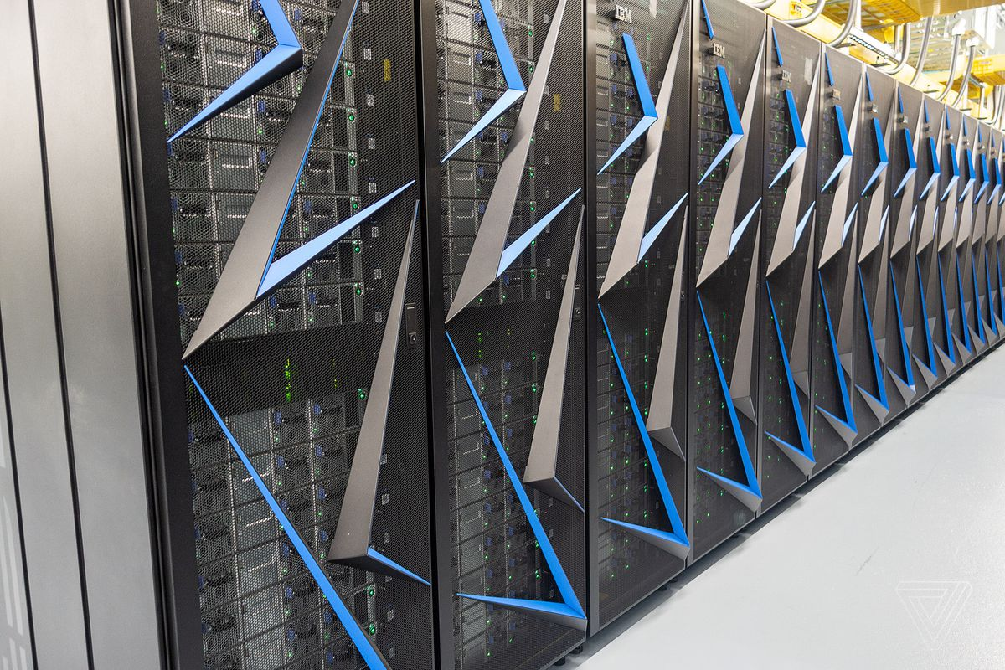

**Purpose** Scientific research

**Comparison of my PC with Supercomputer**

|  |  |  |
| --- | --- | --- |
| Specifications | HP EliteBook 840 | SUMMIT IBM |
| Storage | 1 TB | 250 PB |
| Speed | Intel Core i5-4300U | 200 petaflops (peak) |
| Power | 12 V | 13 MV |
| Architecture | CPU 1.90 GHz 2.50 GHz | 9,216 POWER9 22-core  CPUs 27,648 Nvidia Tesla V100 GPUs |

**References**

1. A. H. Baker, D. M. Hammerling, M. N. Levy, H. Xu, J. M. Dennis, B. E. Eaton, J. Edwards, C. Hannay, S. A. Mickelson, R. B.. 2015. A New Ensemble-Based Consistency Test for the Community Earth System Model (pyCECT v1.0). Geoscientific Model Development 8, 9 (2015), 2829--2840.
2. D. J. Milroy, A. H. Baker, D. M. Hammerling, and E. R. Jessup. 2017. Geoscientific Model Development Discussions 2017 (2017), 1--22.